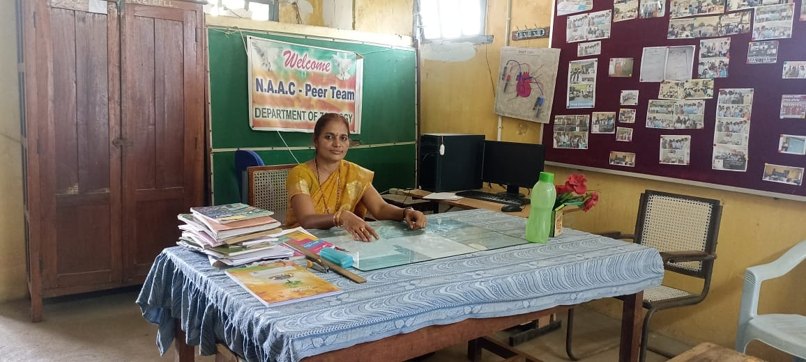

CURRICULUM VITAE OF Dr.T.KUSUMA KUMARI.

Name | Dr.T.KUSUMA KUMARI
Gender | Female
Father’s Name | T.J.KRISHNA REDDY
Mother’s Name | T.SATYAVATHI
D.O.B | 15.07.1974
Marital status | Married
Spouse | N.Raghu Rama Reddy
Community | OC-Reddy
Religion | INDIAN-Hindu
Address For Communication | Dr.T.Kusuma Kumari  Faculty of zoology  S.V.R.K. GDC (M),NIDADAVOLE-534301,E.G,A.P  Mobile No : 6300413198  E.Mail:kusuma.terala2010gmail.com
Residential Address | Dr.T.KUSUMA KUMARI  H.NO: 4-156-3,ELI ANJANEYA COLONY,TADEPALLIGUDEM-534101,W.G.Dt
Languages Known | Telugu,Hindi &English

Educational Qualifications

Name of the degree | University | Year of Passing | Percentage
M.Sc. | Annamalai University | 2001 | 60.35% | Zoology
PGDES | Andhra university | 2002 | 65.5%
AP SET | Andhra University | 2020 | 55% | Life Sciences
Ph.D | Acharya Nagarjuna university | 2022 | - | ZOOLOGY

Paper publications

Title | Year of Publication | ISSN .NO | Name of the Journal | Links
HISTOPATHOLOGICAL CHANGES IN  THE GILL, LIVER, AND KIDNEY OF THE  FISH LABEO ROHITA (HAMILTON)  EXPOSED TO THIODICARB 75% WP | 11.12.2017 | 9700765 | Bulletin in pure & applied sciences | https://drive.google.com/file/d/0B2RAGhiOYdz8MW5OZ3RWbUN2RFVrV0YzWGtPOXRXaWFyQ2Rn/view?usp=share_link&resourcekey=0-JVOM3Efa7q9gyP  xNFR-vrw
Phenthoate 50% EC Toxicity and Its Impact on  Aminotransferases of Freshwater Fish Catla (Gibelion catla) | Jan.2018 | 2319-7676 | IOSR | https://drive.google.com/file/d/1Q71EzE5RM5ZCTgd-V33dvzQgvRc0b_Sh/view?usp=share_link
Effect of Phenthoate 50% EC on Oxygen Consumption of Freshwater Fish Catla  catla | Nov.2018 | 2319-7064 | IJSR | https://drive.google.com/file/d/1pAqnZiLCMJMq9lyPq9sjoQIt5uBz22-6/view?usp=share_link

Seminars / Work shops and Events attended
S.No | Name of the program | Organised by | Dates | Title
1 | National Seminar | Dept. Of Zoology DNR.College,Bhimavaram | 5.10.2009 | Emerging trends in Aquaculture
2 | National Seminar | SRR&CVR.Govt.college,Vijayawada | 7.1.2010 | Recent trends in Aquaculture
3 | National Seminar | Dept.of Economics.Dharma AppaRao college,Nuzvid | 8.9.2011 | Movement of Self Help Groups
4 | National Seminar-Paper Presentation | V.S.M.College,Ramachandrapuram | 16.9.2011 | Rural Development.
5 |  | S.C.I.M. Govt. Degree college,Tanuku. | 13.9.2014 | One day Teacher development & skill update workshop
6 | 3 DaysTraining Program For Trainers | CCE& TISS | 11.2.2016 To 13.2.2016 | Introduction to Entrepreneurship
7 | National seminar | S.V.D.GDC ( W },Nidadavole. | 26.2.2016 | Innovation through Biotechnology is a Pleasant Responsibility
8 | One day State level Work shop | S.V.R.K.GDC ( M ),Nidadavole. | 29.10.2019 | Enhancement of Internal Quality & NAAC Accreditation.
9 | One day National work shop. | S.V.R.K.GDC ( M ), Nidadavole. | 11.3.2020 | Intellectual Property Rights.
10 | 5 days FDP | CCE | 6.7.2020 To 10.7.2020 | New knowledge in Animal sciences- emerging technologies in molecular biology.
11 | Webinar | P.R.College,Kakinada. | 31.05.2020 | A paradigm shift in the post covid world
12 | National Seminar | KVR GDC(A), Cluster university, Kurnool | 15.10.2022 | Emerging areas of biotechnology
13 | International Webinar | GDC (A),Ananthapuram | 22.10.2022 | New trends & approaches in drug development.
14 | 5 Days Residential Training Program for Teachers | CCE,ANU-Guntur | 2.11.22 To 6.11.2022 | Content delivery- Skill Courses-Poultry Farming
15 | 3 Days Non Residential Training Program | N.R.C. Rajahmahendravaram. | 6.2.2023 To 8.2.2023

Experience:-
- 17 years Experience as Degree College Lecturer.
- At Present working at S.V.R.K.GDC (M), Nidadavole Since29 th July 2019.

Strengths :-
- Communication skills.
- Commitment.
- Positive attitude.

I hereby declare that the above details are true to the best of my Knowledge and Iam Personally responsible for the authenticity of the same.

(Dr. T.KUSUMA KUMARI )

